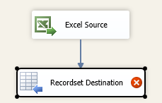

First, define a user variable of type "object".

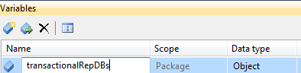

Then map the variable with the **Recordset Destination** object.

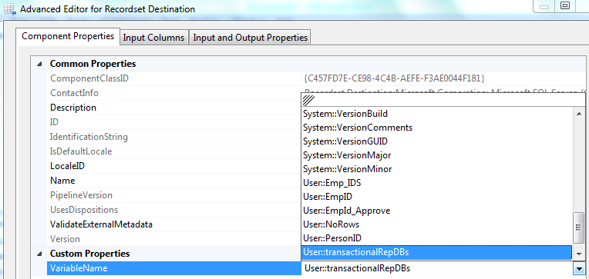

Listed below is the code I used to load a datatable in a C# script task from a recordset or resultset variable. **"User::transactionalRepDBs**" is a SSIS variable of Object (System.Object) that was loaded through a "Full result set" from a execute SQL task script.

using System.Data.OleDb;

DataTable dt= new DataTable();

OleDbDataAdapter adapter = new OleDbDataAdapter();

adapter.Fill(dt, Dts.Variables["User::transactionalRepDBs"].Value);

foreach (DataRow row in dt.Rows)

{

//insert what you want to do here

}

**OTHER OPTION**

Dim oleDA As New OleDbDataAdapter

Dim dt As New DataTable

Dim col As DataColumn

Dim row As DataRow

Dim sMsg As String

Dim sHeader As String

oleDA.Fill(dt, Dts.Variables("User::transactionalRepDBs").Value)

If dt.Rows.Count > 0 Then

Dts.Variables("uvErrorEmailNeeded").Value = True

For Each col In dt.Columns

sHeader = sHeader & col.ColumnName & vbTab

Next

sHeader = sHeader & vbCrLf

For Each row In dt.Rows

For Each col In dt.Columns

sMsg = sMsg & row(col.Ordinal).ToString & vbTab

Next

sMsg = sMsg & vbCrLf

Next

Dts.Variables("uvMessageBody").Value = "Error:" & vbCrLf & sHeader & sMsg & vbCrLf & vbCrLf

End If

Dts.TaskResult = Dts.Results.Success